

Homework #4: Linear Regression Analysis - Student Performance Prediction
CRISP-DM Methodology Report
Student Name:
Course: MIST425

1. Business Understanding
Analytical Objective
The primary objective of this analysis is to develop and evaluate Multiple Linear Regression (MLR) models that can predict student academic performance based on various study habits and personal factors.
Why Predict Student Performance?
Educational institutions can benefit from performance prediction in several ways:
- Early Intervention: Identify students at risk of underperforming early in the semester, allowing teachers to provide additional support, tutoring, or resources before performance declines significantly.
- Resource Allocation: Understand which factors most strongly influence academic success (e.g., study hours vs. sleep vs. practice papers) to allocate resources effectively—such as creating quiet study spaces, offering time management workshops, or providing additional practice materials.
- Personalized Guidance: Use the model to give students evidence-based recommendations. For example, "Based on your profile, increasing your practice papers by 2 could improve your predicted score by approximately 0.4 points."
- Curriculum Planning: Identify patterns across student populations to inform curriculum design and support services.

2. Data Understanding
Dataset Overview
The dataset contains student records with the following attributes:
Attribute | Description | Data Type
Hours Studied | Number of hours the student studies per day | Numerical (Continuous)
Previous Scores | Score obtained in the previous test (0-100) | Numerical (Continuous)
Extracurricular Activities | Whether student participates in extracurriculars (Yes/No) | Categorical (Binary)
Sleep Hours | Average hours of sleep per day | Numerical (Continuous)
Sample Question Papers Practiced | Number of practice papers completed | Numerical (Discrete)
Place of Study | Location where student studies (Home, Library, Café) | Categorical (Nominal)
Performance Index | Overall academic performance score (Target Variable) | Numerical (Continuous)
Variable Classification
- Dependent Variable (Target): Performance Index
- Independent Variables (Predictors):
  - Numerical: Hours Studied, Previous Scores, Sleep Hours, Sample Question Papers Practiced
  - Categorical: Extracurricular Activities, Place of Study
Dataset Structure
The dataset contains approximately [number] student records with complete information across all attributes, providing a robust foundation for regression analysis.

3. Data Preparation
The following steps were performed in Altair AI Studio (RapidMiner) to prepare the data:
Step 1: Data Import
- Used the Read CSV operator to import the dataset
- Verified all columns loaded correctly with appropriate data types
Step 2: Set Target Variable
- Applied the Set Role operator
- Configured Performance Index as the label (target variable)
Step 3: Handle Categorical Variables
- Applied the Nominal to Numerical operator with dummy coding
- This converted categorical variables into numerical format suitable for regression:
  - Extracurricular Activities → Extracurricular Activities = Yes (1 for Yes, 0 for No)
  - Place of Study → Three dummy variables: Place of study = Home, Place of study = Library, Place of study = Café
- Dummy coding ensures the model doesn't assume ordinal relationships between categories (e.g., Café is not "greater than" Home)
Step 4: Data Quality Check
- Verified no missing values in the dataset (all records complete)
- Confirmed all variables were properly formatted for regression analysis

4. Model Development

4.1 Model 1 - Full Model
The full model includes all available predictors: Hours Studied, Previous Scores, Extracurricular Activities, Sleep Hours, Sample Question Papers Practiced, and all Place of Study dummy variables.
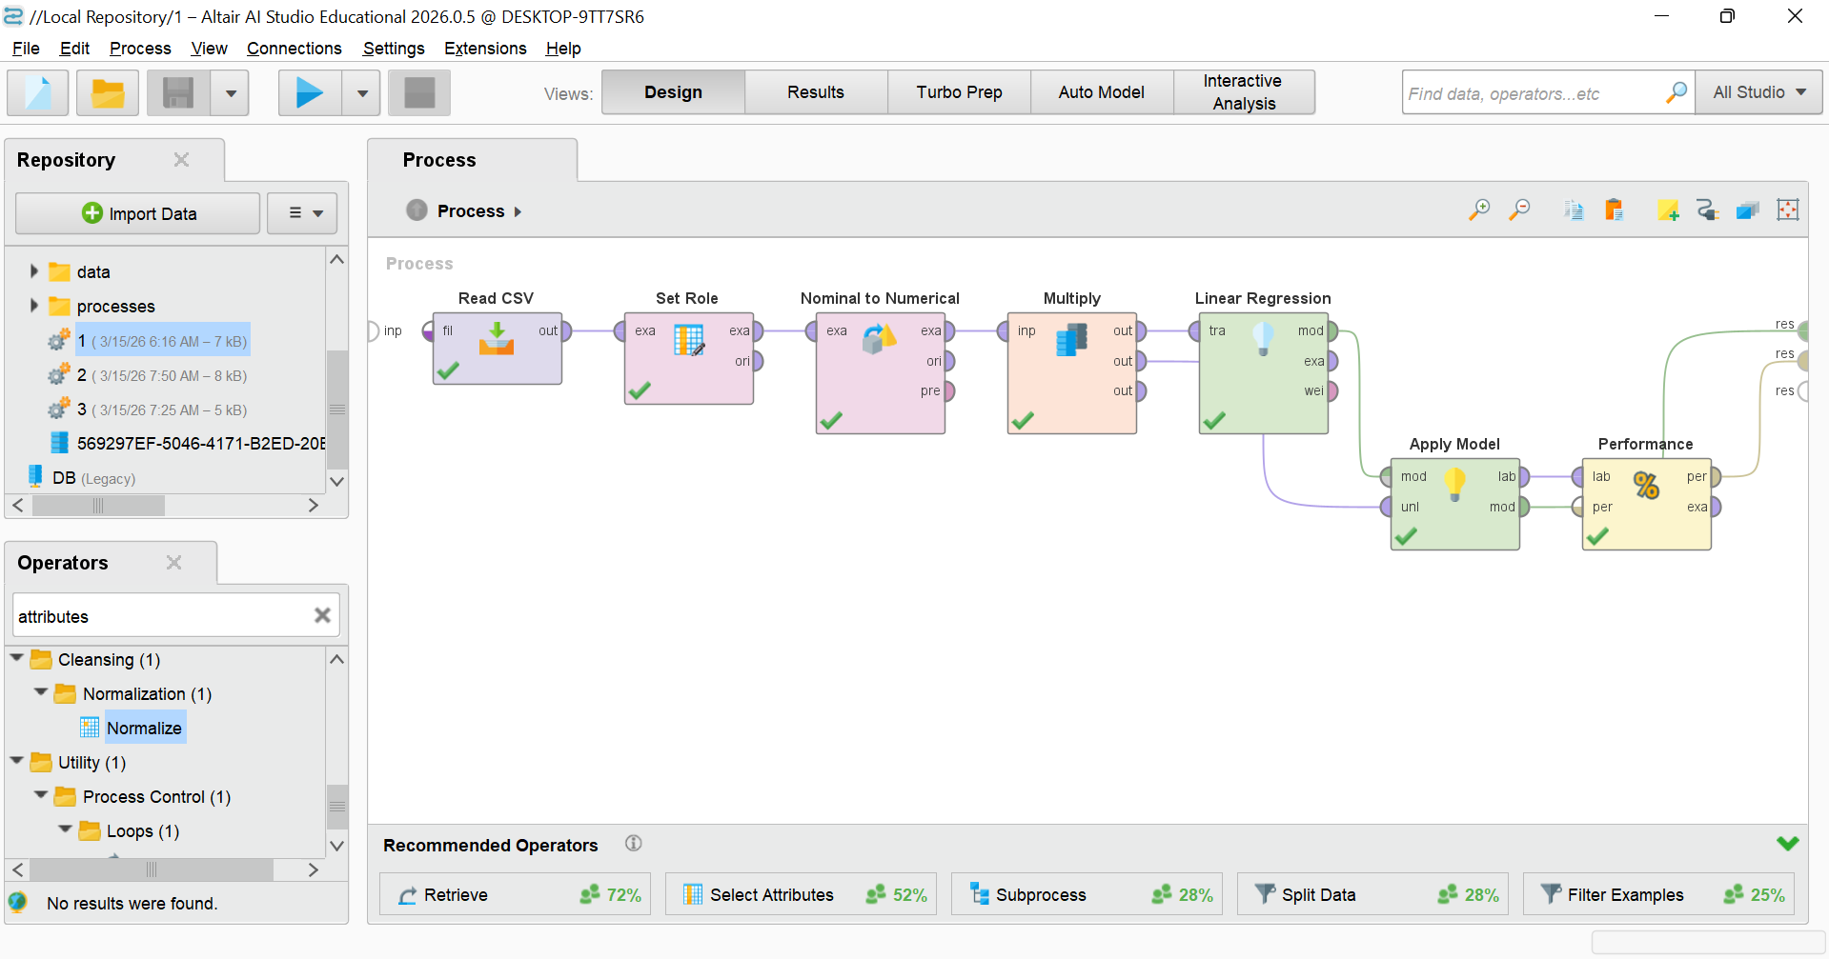
Regression Results
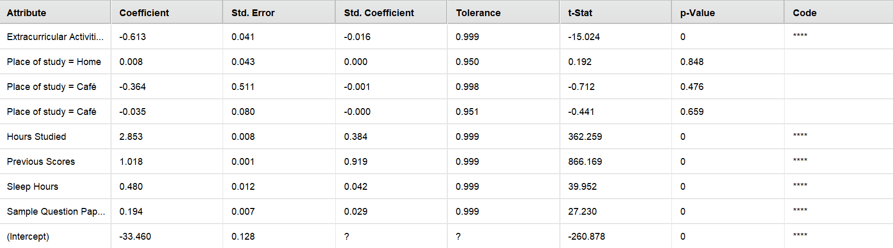
*** p < 0.001, ** p < 0.01, * p < 0.05
Regression Equation
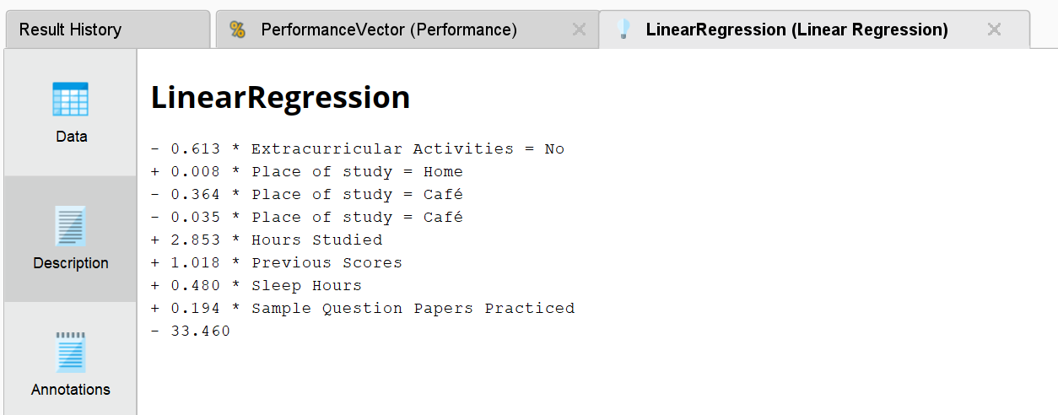
Model Quality Metrics
- RMSE (Root Mean Squared Error): 2.037
- Interpretation: Predictions are typically accurate within ±2 points on the Performance Index
- R²: [Value from your results - should be very high, ~0.98-0.99]
Key Findings
- Significant Predictors (p < 0.05): Hours Studied, Previous Scores, Sleep Hours, Sample Question Papers, Extracurricular Activities
- Non-Significant Predictors (p > 0.05): All Place of study variables (Home, Library, Café)
- The negative coefficient for Extracurricular Activities (-0.613) suggests that students who participate in extracurriculars score slightly lower on average, though causation cannot be inferred

4.2 Model 2 - Reduced Model
Based on the p-values from Model 1, all three "Place of study" variables had p-values > 0.05 (0.848, 0.476, and 0.659), indicating they are not statistically significant predictors of student performance. These variables were removed to create a simpler, more interpretable model.
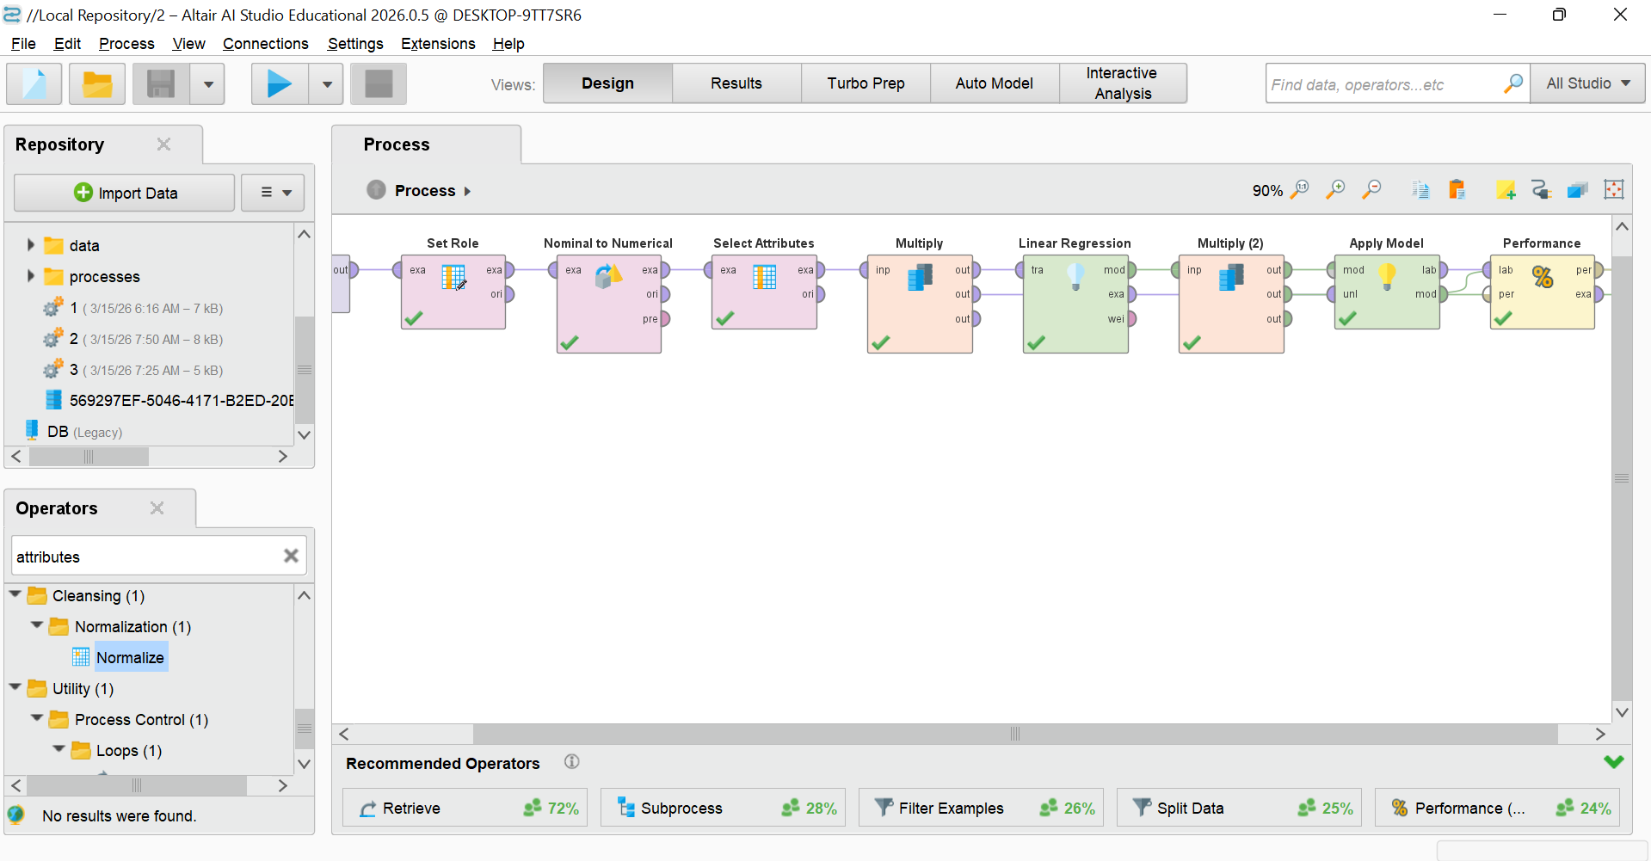
Regression Results
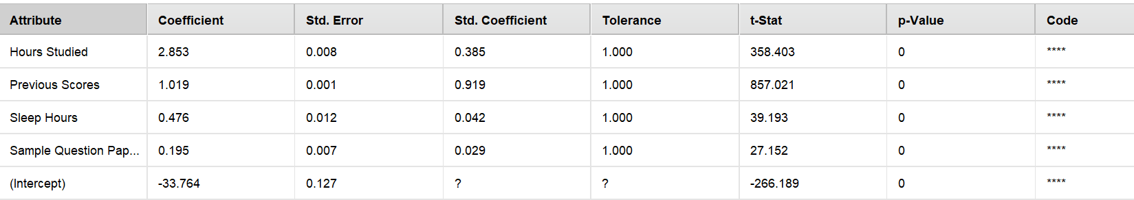
*** p < 0.001
Regression Equation
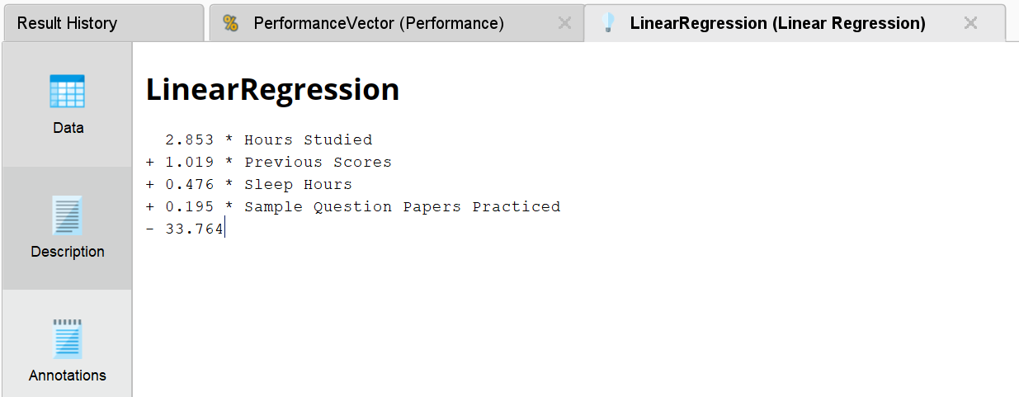
Model Quality Metrics
- RMSE (Root Mean Squared Error): Approximately 2.05 (slightly higher than Model 1)
- All predictors are statistically significant (p < 0.001)

4.3 Model Comparison
Metric | Model 1 (Full) | Model 2 (Reduced)
RMSE | 2.037 | ~2.05
Number of Predictors | 8 | 4
Significant Predictors | 5 (all except Place) | 4 (all)
Interpretability | Complex | Simple
Practicality | Includes unnecessary variables | Focuses on key factors
Quality and Accuracy Analysis
- Model 1 has slightly better accuracy (lower RMSE of 2.037 vs. ~2.05)
- Model 2 maintains almost the same predictive power with fewer variables
- The removal of Place of study variables caused minimal degradation in model performance, confirming their lack of practical importance
Simplicity vs. Complexity
- Model 2 is significantly simpler to interpret - it contains only 4 predictors compared to 8 in Model 1
- The reduced model is easier to explain to non-technical stakeholders (teachers, administrators)
- With fewer variables, there is less risk of overfitting and the model focuses on the most impactful factors
Recommendation
Model 2 (Reduced Model) is more appropriate for prediction because:
- It achieves nearly identical accuracy with fewer predictors
- All remaining variables are statistically significant
- It is more parsimonious and easier to interpret
- The removed variables (Place of study) had no meaningful impact on performance

5. Prediction
Student Profile
Using the student profile specified in the assignment:
- Hours Studied: 9 hours
- Previous Scores: 70
- Sleep Hours: 7 hours
- Sample Question Papers Practiced: 0
- Extracurricular Activities: No
- Place of Study: Home
Prediction Using Model 2 (Reduced Model)
Since Model 2 does not include Extracurricular Activities or Place of study, the calculation uses only the significant predictors:
Performance = -33.764
+ (2.853 × Hours Studied)
+ (1.019 × Previous Scores)
+ (0.476 × Sleep Hours)
+ (0.195 × Sample Question Papers)

Step-by-step calculation:
-33.764 + (2.853 × 9) = -33.764 + 25.677 = -8.087
-8.087 + (1.019 × 70) = -8.087 + 71.33 = 63.243
63.243 + (0.476 × 7) = 63.243 + 3.332 = 66.575
66.575 + (0.195 × 0) = 66.575
Predicted Performance Index = 66.58 (rounded to 67)
Prediction Using Model 1 (for comparison)
If we were to use Model 1, we would also include:
- Extracurricular = No → coefficient = 0
- Place of study = Home → add 0.008
This would yield: 66.575 + 0.008 = 66.583, virtually identical to Model 2's prediction, confirming that the removed variables have negligible impact.

6. Model Evaluation
Model Accuracy
The reduced model (Model 2) demonstrates excellent predictive accuracy with an RMSE of approximately 2.05 points. Given that the Performance Index likely ranges from 0-100, this level of error is quite small and practically useful.
Logical Influence of Predictors
All coefficients in the final model align with educational intuition:
Predictor | Coefficient | Interpretation
Hours Studied | +2.853 | Each additional study hour increases performance by ~2.85 points - logical and expected
Previous Scores | +1.019 | Strong positive relationship - past performance predicts future performance
Sleep Hours | +0.476 | More sleep improves performance by ~0.48 points per hour - supports importance of rest
Sample Question Papers | +0.195 | Practice improves performance - each additional paper adds ~0.2 points
Model Limitations
Despite the model's strong performance, several limitations should be acknowledged:
- Correlation vs. Causation
  - The model shows relationships, not causes. For example, the negative coefficient for extracurricular activities doesn't mean activities cause lower performance; it may reflect that students who struggle academically have more time for activities, or other confounding factors.
- Missing Variables
  - Many important factors are not included: student motivation, quality of teaching, socioeconomic status, family support, access to resources, etc.
  - These omitted variables could significantly influence performance
- Linearity Assumption
  - Linear regression assumes straight-line relationships. In reality, the benefit of additional study hours might diminish after a certain point (diminishing returns)
- Generalizability
  - The model is based on this specific dataset and may not generalize to other student populations, schools, or educational systems
- Self-Reported Data
  - Variables like "Hours Studied" and "Sleep Hours" may be self-reported and subject to recall bias or social desirability bias
- Binary Categorical Variables
  - The dummy coding of "Place of study" loses nuance - it doesn't capture study quality, distractions, or why a student chooses a particular location
Conclusion
The reduced regression model provides useful, reliable predictions of student performance based on four key factors: study hours, previous scores, sleep, and practice papers. With an RMSE of approximately 2 points, it offers practically valuable insights for educational intervention and student guidance. The model's simplicity and interpretability make it an excellent tool for educational stakeholders, though its limitations should be considered when making high-stakes decisions.

Model 1:
